Phylogenetic Trees: United, but Diverse

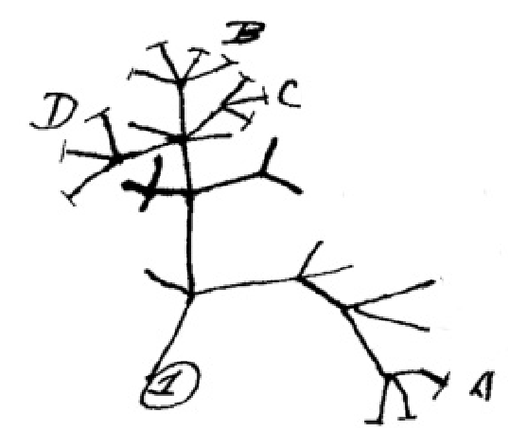
Illustration from Charles Darwin’s notebook (1837)

SCENARIO: The Biology Department at your local college is looking to hire paid interns who will assist in the development of the Evolutionary Relationships course (Bio 327). You and your lab partners are definitely interested in this opportunity and attend the information session.

You meet Dr. Wallace-Darwin, a Science Education research fellow, who is screening potential applicants for intern positions. She states that only applicants who successfully complete an initial diagnostic assessment will be offered one of the internships. Still interested, you request the assessment materials.

Section 1: Diagnostic Assessment – Alien Phylogenetics

Using CARD SET A, complete the following tasks and submit them for approval to Dr. Wallace-Darwin. Good Luck!

Task #1 – Arrange the cards based on shared characters to establish a hypothesis about the relationships between these species.
Task #2 – Complete Character Matrix
Task #3 – Complete Phylogenetic Tree
Task #4 – Complete Dichotomous Key
Task #5 – Complete Analysis Questions
Request Teacher Feedback. Approved ______ Revised ______ Submit completed files for Dr. Wallace-Darwin’s approval.
= Indicates that a worksheet is needed

Name: Character Matrix

Instructions: For each species, mark an “X” for each character present. Using the information in this matrix, arrange the species based on their shared characters to fill in the phylogenetic tree below.

CHARACTER | A2E | A7V | A4O | A6L | A1U | A3T | A9I | A5O | A8N
SIX LEGS
WINGS
STINGER
STAR BELLY
CLAWS
LONG LEGS
LOSS OF ARMS
EYE STALKS
ANTENNAE

NAME: PHYLOGENETIC TREE

Instructions: Using the information from your character matrix, arrange the alien species based on their shared characters. Identify the evolution of new (derived) characters and label them at the appropriate branch on the tree. At the tip of each branch, identify the species using the dichotomous key provided.

Name: _____________________ Dichotomous Key

Instructions: A dichotomous key is an organized set of couplets of mutually exclusive characteristics that is used to identify biological organisms. Use the key below to identify each alien species. Write the genus species by the appropriate serial number at the end of this key.

1a – Has 4 legs…………………………………………………………………………………..………………Go to STEP 2
1b – Has 6 legs…………………………………………………………………………………..………..……Go to STEP 5

2a – Has antennae………………………………………...……………………….……..………………...Go to STEP 3
2b – Has no antennae.....…………………….…………………………………………………..………Go to STEP 4

3a – Has long legs………………………………………………………………………………………Globocorpus lata
3b – Has short legs…………………………………………………………………………….. Globocorpus auribus

4a – Has star belly and no eye stalks……………………………………….…………. Globocorpus stellans
4b – Has star belly and eye stalks…………………………………………………… Globocorpus longoculus

5a – Has wings………………………………………………………………………………………….……….Go to STEP 6
5b – Has a stinger……………………………………………………………………………………………...Go to Step 7

6a – Has arms……………………………………………………………………………………….. Hexapedes elegans
6b – Has no arms……………………………………………………………………….…………. Hexapedes volantis

7a – Has claws……………………………………………………………………..…………………………… Go to Step 8
7b – Has no claws………………………………………………………………………………….. Hexapedes aculeus

8a – Has antennae…………………………………………………………….……………………. Hexapedes odoror
8b – Has no antennae……………………………………………………..……………………… Hexapedes ungula

A1U: A6L:
A2E: A7V:
A3T: A8N: A4O: A9I:
A5O:

Analysis Questions of Diagnostic Assessment

- The phylogenetic tree that you completed in the lab investigation is also known as a:

  - cladogram
  - evolutionary diagram
  - flow chart
  - genetic map
  - morphological diagram

- Which of the following best explains what a cladogram is?

  - a map showing the geographical location of species
  - a visualization of the chromosomal similarities between species
  - a diagram of the analogous similarities between species
  - a diagram of the evolutionary relatedness of species with branches not drawn to scale E) a visualization of the location of genes on chromosomes

- Which two phylogenetic trees (cladograms) depict the same evolutionary relationships between species A, B, C and D? Explain your answer.

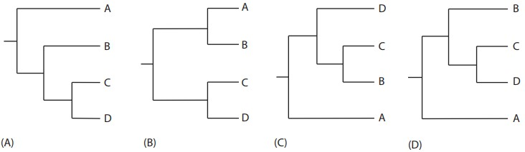

- Draw a new phylogenetic tree that depicts the same evolutionary relationships as the tree below. Your new tree must change the order of species in at least two positions.

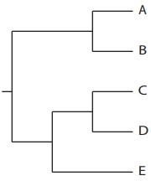
State University at Yorkville
Department of Biology
Dear Applicant:

Congratulations! Based on your performance, you have been selected as an intern for BIO 327: Evolutionary Relationships. We look forward to your participation and your valuable input.

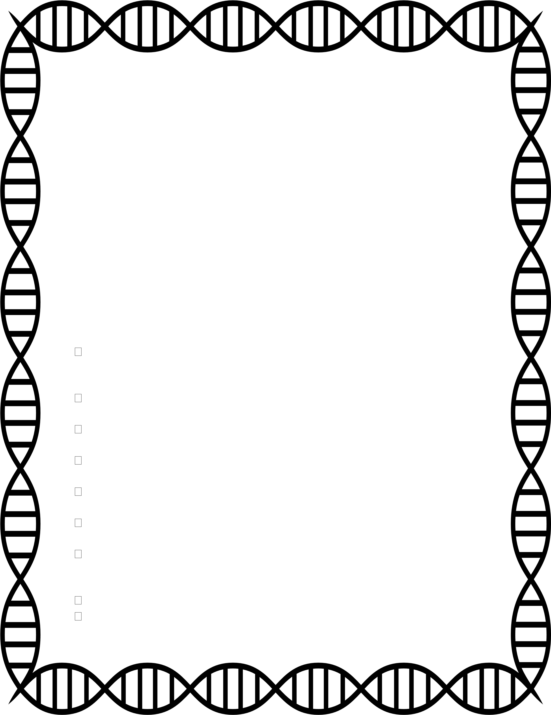
Our department is gathering data on students’ abilities to construct and interpret phylogenetic trees using molecular data. Using your knowledge of Biology, complete each activity and answer the accompanying analysis questions. Thank you in advance for your time and effort in helping us improve this course.

Section 2: Application – Phylogenetic tree construction

Task #1 – Using the ten species from CARD SET B, evaluate the phenotypic characteristics to predict the evolutionary relationships among these ten species.
Task #2 – Based on your prediction in Task #1, draw a phylogenetic tree in Tree A that illustrates the relationships among these species.
Task #3 – Collect DNA sequences for the hemoglobin alpha protein for all 10 species using the NCBI website. See Resource #1.
Task #4 – Analyze the DNA sequences to build a phylogenetic tree using the web-service Phylogeny.fr. See Resource #2.
Task #5 – Draw this phylogenetic tree in Tree B and complete the analysis questions.
Task #6 – Choose an 11th “discovery” organism and draw its predicted location on Tree B.
Task #7 – Collect the hemoglobin alpha DNA sequence for this species from NCBI, add it to previous data, and reanalyze the phylogenetic relationships using Phylogeny.fr.
Task #8 – Draw the updated phylogeny in Tree C.
Task #9 – Submit your completed application to Dr. Wallace-Darwin for evaluation.

NAME: Phenotypic vs. Molecular Data

Tree A: Construct a phylogenetic tree for 10 species based on phenotypic characteristics.

Tree A Analysis Questions:

- Identify at least three characteristics that all 10 species have in common.

- Explain how shared, derived characteristics are used to infer evolutionary relationships.

- Select a group of closely related species from your phylogenetic tree and explain why you have grouped them together.
- Select two species that are distantly related on your phylogenetic tree and describe at least two phenotypic characteristics that distinguish them from one another.

- What additional data could be incorporated to strengthen your hypothesis about the evolutionary relationships between these species?

Tree B: Draw the phylogenetic tree for the 10 species generated by Phylogeny.fr based on DNA sequences. Your tree should reflect the correct branching order of these species.

Note: The branch lengths and red numbers that indicate confidence estimates are not important for Tree B analysis. However, these data points may be needed in the future.

Tree B Analysis Questions:

- Hemoglobin is an oxygen-transport protein that is found in the red blood cells of almost all vertebrates. It has four subunits: two alpha subunits and two beta subunits. Explain how this protein is produced from the DNA sequences you just collected.

- Identify the similarities and differences between the phenotypic phylogeny (Tree A) and molecular phylogeny (Tree B)?

- The phylogeny you built using molecular data correctly assigns the nine mammalian species to their respective orders (i.e., primates, carnivores, and rodents), and identifies the chicken as an evolutionarily distant outgroup. Are the specific branching patterns within these three orders the same as your original predictions in Tree A? Are the species in these orders equally related to one another? Explain.

Now choose a Discovery Species _________________________ Using a colored pencil, predict where the Discovery Species would fit in Tree B. Draw it in.

- Explain your reasoning for placing the Discovery Species in this phylogenetic position.

Tree C: Draw the revised phylogenetic tree generated by Phylogeny.fr after adding the DNA sequence of the 11th species.

For this analysis, consider the confidence estimates for each node, which are indicated in red.

Tree C Analysis Questions:

- Is the phylogenetic placement of your Discovery species consistent with your original prediction? If not, identify an additional phenotypic characteristic(s) that supports the updated molecular phylogeny.

- On the Phylogeny.fr screen, click on the 3. Alignment tab. What information is presented? How is it relevant to understanding the evolutionary relationships between species?

- Today, you compared the evolutionary relationships among species using the DNA sequence for the hemoglobin alpha protein. If we repeated this analysis using the DNA sequence of another protein, would you predict the evolutionary relationships to stay the same? Why or why not?

- You constructed a phylogenetic tree based on molecular data for a single protein. Would it be beneficial to repeat this analysis using molecular data from more than one protein? If so, why?

- The numbers in red indicate the confidence estimates for each node. If you repeated the analysis using multiple proteins, would you predict most of the values to increase or decrease? Why?

- Two species are that are distantly related based on the analysis of multiple DNA sequences also share a set of very similar phenotypic characteristics, such as the presence of wings in both bats and chickens. Consider and discuss what evolutionary process could lead to this pattern?

f) In this activity, you used several analyses and types of data to explain the evolutionary relationships among a set of present-day species. How do these activities model the process of science?

RESOURCE #1: Using the Website NCBI.

https://www.ncbi.nlm.nih.gov/
- What is NCBI? A free web service focused on providing genomic resources further the National Institute of Health’s mission of “uncovering new knowledge”.
- How do I use NCBI?
a) For our purposes, you will be searching for the DNA sequence of Hemoglobin alpha of your specific species.
à We want to access a specific database to find the nucleotides of our DNA sequence. à Click the dropdown menu for “All Databases” and select NUCLEOTIDE.

Common name | Scientific name
Dog | Canis lupus
Tiger | Panthera tigris
Mouse | Mus musculus
Hamster | Cricetulus griseus
Polar Bear | Ursus maritimus
Macaque | Macaca mulatta
Rat | Rattus norvegicus
Human | Homo sapiens
Chicken | Gallus gallus
Chimpanzee | Pan troglodytes
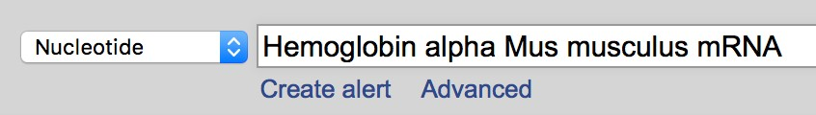
- In the blank box to the right, type Hemoglobin alpha, your species’ scientific name and mRNA. mRNA stands for messenger RNA and is needed for our search. An example using mouse is provided below.

- Click SEARCH
*Special note for searching Human (Homo sapiens)
Because there is so much genetic information available online for humans, you will need to take an extra step after searching “Hemoglobin alpha Homo sapiens mRNA”.
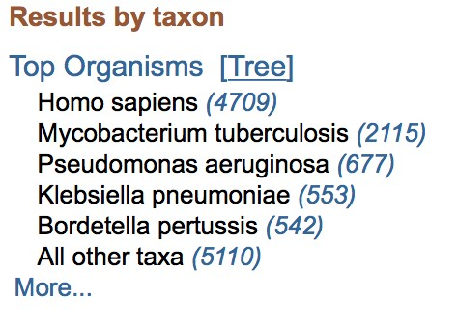
In the top right corner on the NCBI website, there should be a list of the number of results from your search, organized by species. Click on the number next to Homo sapiens.

This will restrict your search results, so it will be easier to find the correct nucleotide sequence. You are now ready to continue.
- Select the result where “hemoglobin alpha” or “hemoglobin alpha 1” is mentioned in the
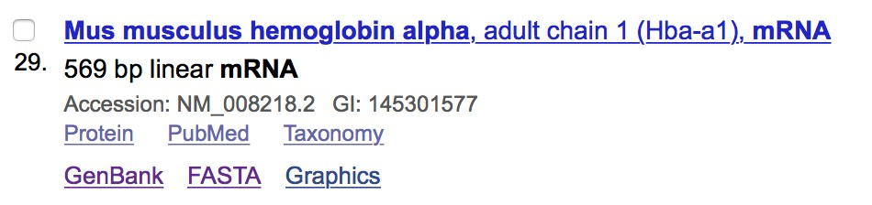
ALWAYS double check that the selected result results and click FASTA. contains the correct genus species AND
Hemoglobin alpha in the link! The result you need may not always be listed first. Here our example is the 29th result, rather than first
five shown.
No alpha stabilizing protein! No Beta! No Mu!

- The next screen will show the DNA sequence for Hemoglobin alpha for your specific species. An example is shown below. COPY ONLY the nucleotides
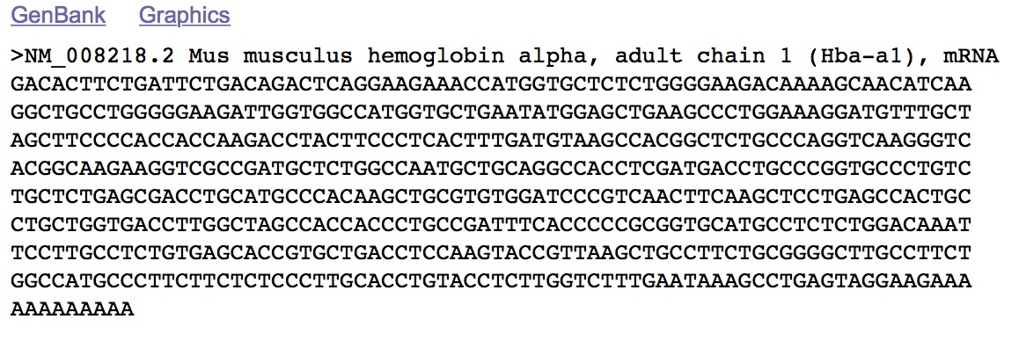

- In a separate document, type a “greater than” symbol (>) and then the name of the species. A Microsoft Word document or Google doc are acceptable.

- PASTE the DNA sequence underneath. An example for mouse is shown below:
> Mouse Mus musculus
GACACTTCTGATTCTGACAGACTCAGGAAGAAACCATGGTGCTCTCTGGGGAAGACAAAAGCAACATCAA
GGCTGCCTGGGGGAAGATTGGTGGCCATGGTGCTGAATATGGAGCTGAAGCCCTGGAAAGGATGTTTGCT
AGCTTCCCCACCACCAAGACCTACTTCCCTCACTTTGATGTAAGCCACGGCTCTGCCCAGGTCAAGGGTC
ACGGCAAGAAGGTCGCCGATGCTCTGGCCAATGCTGCAGGCCACCTCGATGACCTGCCCGGTGCCCTGTC
TGCTCTGAGCGACCTGCATGCCCACAAGCTGCGTGTGGATCCCGTCAACTTCAAGCTCCTGAGCCACTGC
CTGCTGGTGACCTTGGCTAGCCACCACCCTGCCGATTTCACCCCCGCGGTGCATGCCTCTCTGGACAAAT
TCCTTGCCTCTGTGAGCACCGTGCTGACCTCCAAGTACCGTTAAGCTGCCTTCTGCGGGGCTTGCCTTCT
GGCCATGCCCTTCTTCTCTCCCTTGCACCTGTACCTCTTGGTCTTTGAATAAAGCCTGAGTAGGAAGAAA AAAAAAAAA
Do not let your word processor program change the “greater than” symbol (>) to a different type of bullet. If it does, change it back to the simple > symbol.

h) Repeat for each species until all ten DNA sequences are in one document.

Let’s Build a Phylogenetic Tree! SEE RESOURCE #2
RESOURCE #2: Using the Website Phylogeny.fr
www.phylogeny.fr

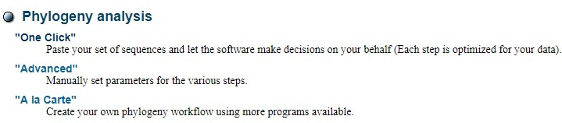
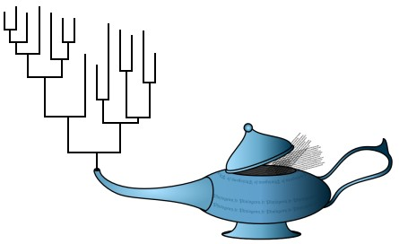
1) What is Phylogeny.fr? A free, simple-to-use web service dedicated to reconstructing and analyzing phylogenetic relationships with molecular sequences. 2) How do I use Phylogeny.fr? phylogenetic analysis.
a)
For our purposes, you will be using the “One Click” option of
à

Scroll down below the genie lamp and select
“One Click”

b)

You may title your work,
“Phylogenetic Tree w/Molecular Data”

in the analysis box here:

c) The file you created that contains the DNA sequences for Hemoglobin alpha is known as a FASTA file. You will now use this FASTA file to build a phylogenetic tree.
à Copy all of the data in your FASTA file, starting with the > symbol and scientific name of your first species, and ending with the last nucleotide of your last species. à Paste all of the data in the box and click SUBMIT.
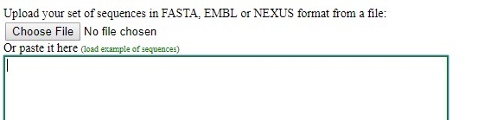
d) Wait patiently. Each nucleotide essentially represents a character (like in the matrix of the aliens) and the program runs an algorithm to determine the maximum likelihood tree. e) Draw the phylogenetic tree in TREE BOX B.
Where does the Discovery Species fit in?
See your student guide and RESOURCE #2 for further details.
Go back to your existing Phylogeny.fr window and click Data & Settings
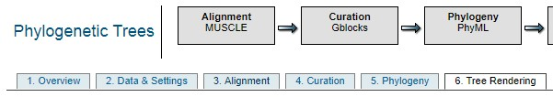
- In the box, underneath the last DNA Sequence, skip a space and add a > and the name of the discovery species.
For example: > Hedgehog Erinaceus europaeus
- Using Resource #1, SEARCH the DNA sequence for Hemoglobin alpha of the discovery species, and then PASTE the DNA sequence underneath the last species in your original list.

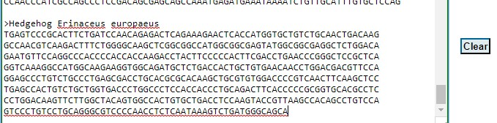

- Click SUBMIT and view the altered phylogenetic tree.
- Copy the tree into the box for TREE C and answer the Analysis Questions.

